Extreme Programming (XP)

🧠 Definition
# Source: AI Source: Provided by: [Data Path: Persons Table -> ID Column: 1, Name_En Column: Motasem Essam] -> From: [ChatGPT] on [1/23/2026]
Extreme Programming (XP) is an Agile framework that focuses on high-quality software, continuous feedback, and strong engineering practices. It emphasizes frequent releases, close customer collaboration, and disciplined coding techniques.
Extreme Programming (XP) is an Agile methodology designed to improve software quality and responsiveness to changing requirements through frequent iterations, testing, and developer collaboration.

🔁 How XP Works
# Source: AI Source: Provided by: [Data Path: Persons Table -> ID Column: 1, Name_En Column: Motasem Essam] -> From: [ChatGPT] on [1/23/2026]
- Development is done in short iterations (1–2 weeks)
- Frequent releases of small features
- Continuous customer involvement and feedback
- Strong focus on coding standards and testing

⚙️ Core Values of XP
# Source: AI Source: Provided by: [Data Path: Persons Table -> ID Column: 1, Name_En Column: Motasem Essam] -> From: [ChatGPT] on [1/23/2026]
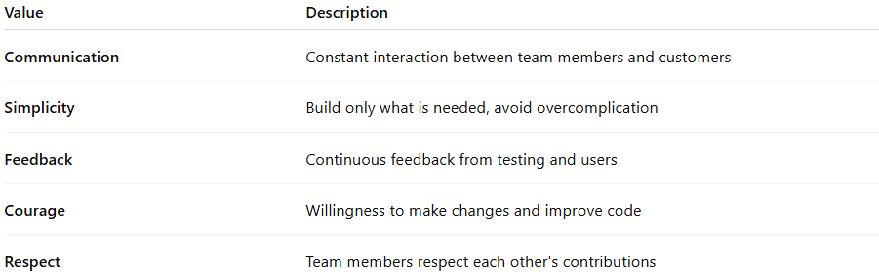
Value | Description
Communication | Constant interaction between team members and customers
Simplicity | Build only what is needed, avoid overcomplication
Feedback | Continuous feedback from testing and users
Courage | Willingness to make changes and improve code
Respect | Team members respect each other's contributions

🛠️ Key Practices in XP

👨‍💻 Pair Programming
# Source: AI Source: Provided by: [Data Path: Persons Table -> ID Column: 1, Name_En Column: Motasem Essam] -> From: [ChatGPT] on [1/23/2026]
- Two developers work together on the same code
- Improves code quality and knowledge sharing

🧪 Test-Driven Development (TDD)
# Source: AI Source: Provided by: [Data Path: Persons Table -> ID Column: 1, Name_En Column: Motasem Essam] -> From: [ChatGPT] on [1/23/2026]
- Write tests before writing code
- Ensures code meets requirements and reduces bugs

🔄 Continuous Integration
# Source: AI Source: Provided by: [Data Path: Persons Table -> ID Column: 1, Name_En Column: Motasem Essam] -> From: [ChatGPT] on [1/23/2026]
- Code is integrated and tested frequently
- Detects errors early

📦 Small Releases
# Source: AI Source: Provided by: [Data Path: Persons Table -> ID Column: 1, Name_En Column: Motasem Essam] -> From: [ChatGPT] on [1/23/2026]
- Deliver software in small, frequent updates
- Provides quick value to users

🧹 Refactoring
# Source: AI Source: Provided by: [Data Path: Persons Table -> ID Column: 1, Name_En Column: Motasem Essam] -> From: [ChatGPT] on [1/23/2026]
- Continuously improve code structure without changing functionality

📋 Simple Design
# Source: AI Source: Provided by: [Data Path: Persons Table -> ID Column: 1, Name_En Column: Motasem Essam] -> From: [ChatGPT] on [1/23/2026]
- Keep design minimal and focused on current needs

⚙️ Key Characteristics
# Source: AI Source: Provided by: [Data Path: Persons Table -> ID Column: 1, Name_En Column: Motasem Essam] -> From: [ChatGPT] on [1/23/2026]
- Strong focus on technical excellence
- Frequent testing and integration
- Continuous customer involvement
- Emphasis on clean, maintainable code

✅ Advantages
# Source: AI Source: Provided by: [Data Path: Persons Table -> ID Column: 1, Name_En Column: Motasem Essam] -> From: [ChatGPT] on [1/23/2026]
- High-quality and reliable software
- Early detection of bugs
- Flexible to changing requirements
- Strong teamwork and collaboration
- Continuous delivery of working software

⚠️ Disadvantages
# Source: AI Source: Provided by: [Data Path: Persons Table -> ID Column: 1, Name_En Column: Motasem Essam] -> From: [ChatGPT] on [1/23/2026]
- Requires highly skilled and disciplined teams
- Pair programming may increase cost
- Less documentation
- Not ideal for very large or distributed teams

📝 When to Use XP
# Source: AI Source: Provided by: [Data Path: Persons Table -> ID Column: 1, Name_En Column: Motasem Essam] -> From: [ChatGPT] on [1/23/2026]
- Projects with frequently changing requirements
- Small to medium-sized teams
- When high code quality is critical
- Close customer involvement is available

📌 Summary
# Source: AI Source: Provided by: [Data Path: Persons Table -> ID Column: 1, Name_En Column: Motasem Essam] -> From: [ChatGPT] on [1/23/2026]
Extreme Programming (XP) is an Agile framework that emphasizes technical practices like pair programming, TDD, and continuous integration to produce high-quality software. It is ideal for projects that require flexibility, rapid feedback, and strong coding discipline, but it demands skilled teams and active customer participation.

